**Experiment 3.3**

**Student Name:** Sahil Kaundal **UID:** 21BCS8197

**Branch:** CSE (Lateral Entry)  **Section/Group:** 616/A

**Semester:** 6th **Date of Performance:** 09/05/2023

**Subject Name:** Mobile Application Development Lab **Subject Code:** 20CSP-356

1. **Aim:**

Create an Android application for user registration that stores the user details in a database table.

1. **Objective:**

* Understanding of the interactions between user interface and underlying application infrastructure.
* Design an android application which uses database in android studio.

1. **System Requirements:**

* Microsoft Windows 7/8/10 (32-bit or 64-bit)
* 4 GB RAM minimum, 8 GB RAM recommended (plus 1 GB for the Android Emulator)
* 2 GB of available disk space minimum, 4 GB recommended (500 MB for IDE plus 1.5 GB for Android SDK and emulator system image)
* 1280 x 800 minimum screen resolution
* Java JDK5 or later version
* Java Runtime Environment (JRE) 6 Android Studio

1. **Steps/Program:**

**activity_main.xml**

<?xml version="1.0" encoding="utf-8"?>

<androidx.constraintlayout.widget.ConstraintLayout xmlns:android="http://schemas.android.com/apk/res/android"

xmlns:tools="http://schemas.android.com/tools"

android:layout_width="match_parent"

android:layout_height="match_parent"

tools:context=".MainActivity">

<LinearLayout

android:layout_width="match_parent"

android:layout_height="match_parent"

android:orientation="vertical"

tools:context=".MainActivity">

<!--Edit text to enter student name-->

<EditText

android:id="@+id/idName"

android:layout_width="match_parent"

android:layout_height="wrap_content"

android:layout_margin="10dp"

android:hint="Name"

android:minHeight="48dp" />

<!--edit text to enter course-->

<EditText

android:id="@+id/idCourse"

android:layout_width="match_parent"

android:layout_height="wrap_content"

android:layout_margin="10dp"

android:hint="Course"

android:minHeight="48dp" />

<!--edit text to display uid-->

<EditText

android:id="@+id/idUID"

android:layout_width="match_parent"

android:layout_height="wrap_content"

android:layout_margin="10dp"

android:hint="UID"

android:minHeight="48dp" />

<!--edit text for section-->

<EditText

android:id="@+id/idSection"

android:layout_width="match_parent"

android:layout_height="wrap_content"

android:layout_margin="10dp"

android:hint="Section"

android:minHeight="48dp" />

<!--button for adding new student-->

<Button

android:id="@+id/idBtnAddStudent"

android:layout_width="match_parent"

android:layout_height="wrap_content"

android:layout_margin="10dp"

android:text="Add"

android:textAllCaps="false" />

</LinearLayout>

</androidx.constraintlayout.widget.ConstraintLayout>

**MainActivity.java**

package com.example.exp10;

import android.os.Bundle;

import android.view.View;

import android.widget.Button;

import android.widget.EditText;

import android.widget.Toast;

import androidx.appcompat.app.AppCompatActivity;

public class MainActivity extends AppCompatActivity {

private EditText nameEdt, courseEdt, uidEdt, sectionEdt;

private Button addStudentBtnEdt;

private DBHandler dbHandler;

@Override

protected void onCreate(Bundle savedInstanceState) {

super.onCreate(savedInstanceState);

setContentView(R.layout.activity_main);

nameEdt = findViewById(R.id.idName);

courseEdt = findViewById(R.id.idCourse);

uidEdt = findViewById(R.id.idUID);

sectionEdt = findViewById(R.id.idSection);

addStudentBtnEdt = findViewById(R.id.idBtnAddStudent);

dbHandler = new DBHandler(MainActivity.this);

addStudentBtnEdt.setOnClickListener(new View.OnClickListener() {

@Override

public void onClick(View v) {

String name = nameEdt.getText().toString();

String course = courseEdt.getText().toString();

String uid = uidEdt.getText().toString();

String section = sectionEdt.getText().toString();

if (name.isEmpty() && course.isEmpty() && uid.isEmpty() && section.isEmpty()) {

Toast.makeText(MainActivity.this, "Please enter all the data..", Toast.LENGTH_SHORT).show();

return;

}

dbHandler.addNewStudent(name, course, uid, section);

Toast.makeText(MainActivity.this, "Student has been added.", Toast.LENGTH_SHORT).show();

nameEdt.setText("");

courseEdt.setText("");

uidEdt.setText("");

sectionEdt.setText("");

}

});

}

}

**AndroidManifest.xml**

<uses-permission android:name="android.permission.READ_EXTERNAL_STORAGE" />

**DBHandler.java**

package com.example.exp10;

import android.content.ContentValues;

import android.content.Context;

import android.database.sqlite.SQLiteDatabase;

import android.database.sqlite.SQLiteOpenHelper;

public class DBHandler extends SQLiteOpenHelper {

private static final String DB_NAME = "studentdb";

private static final int DB_VERSION = 1;

private static final String TABLE_NAME = "mystudent";

private static final String ID_COL = "id";

private static final String NAME_COL = "name";

private static final String ENTER_COURSE = "course";

private static final String UID = "uid";

private static final String SECTION = "section";

public DBHandler(Context context) {

super(context, DB_NAME, null, DB_VERSION);

}

@Override

public void onCreate(SQLiteDatabase db) {

String query = "CREATE TABLE " + TABLE_NAME + " ("

+ ID_COL + " INTEGER PRIMARY KEY AUTOINCREMENT, "

+ NAME_COL + " TEXT,"

+ ENTER_COURSE + " TEXT,"

+ UID + " TEXT,"

+ SECTION + " TEXT)";

db.execSQL(query);

}

public void addNewStudent(String name, String course, String uid, String section) {

SQLiteDatabase db = this.getWritableDatabase();

ContentValues values = new ContentValues();

values.put(NAME_COL, name);

values.put(ENTER_COURSE, course);

values.put(UID, uid);

values.put(SECTION, section);

db.insert(TABLE_NAME, null, values);

db.close();

}

@Override

public void onUpgrade(SQLiteDatabase db, int oldVersion, int newVersion) {

db.execSQL("DROP TABLE IF EXISTS " + TABLE_NAME);

onCreate(db);

}

}

1. **Result/Output:**

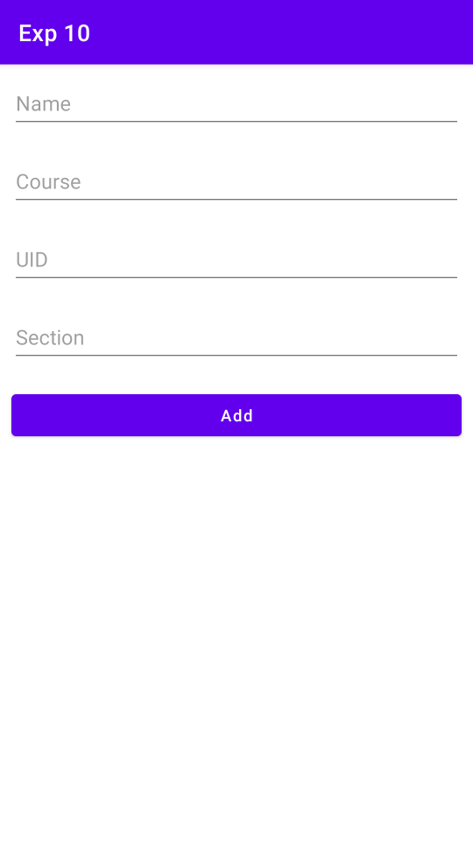 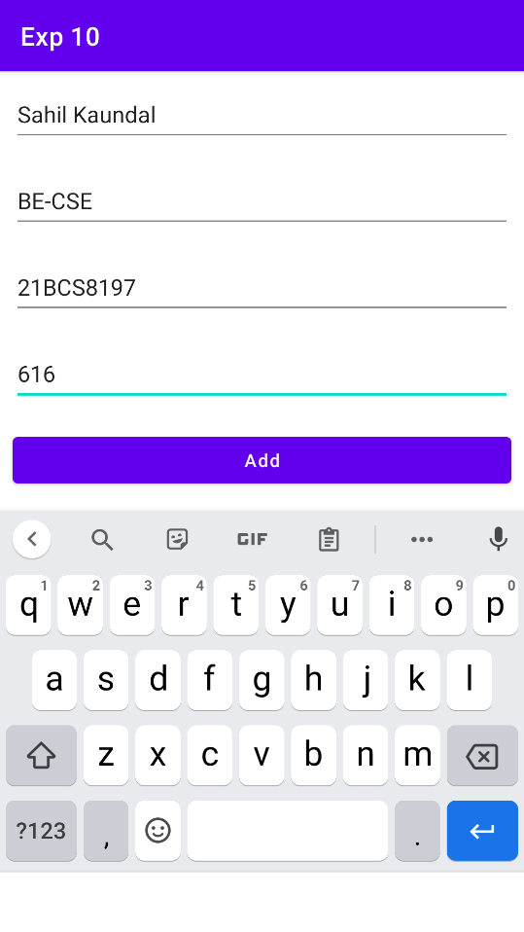

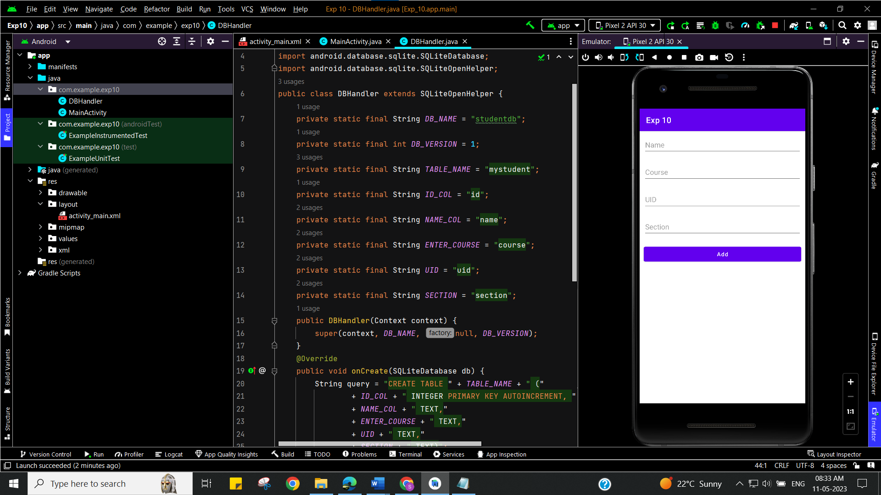

**Learning outcomes (What I have learnt):**

* To design an android application which uses database in android studio.
* Learnt about running application on android studio.